Global Superstore Data Analysis using SQL
- Find the Total revenue, quantities and Profit generated.
-- total revenue
SELECT SUM(Sales) AS total_revenue
FROM superstore;
Result:
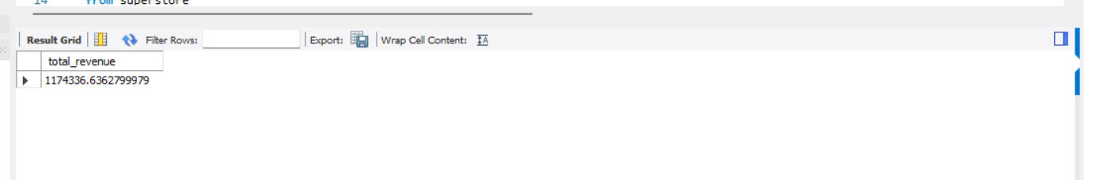
- Find the Segment wise distribution of the Sales.
Code:
select segment, sum(segment) as seg_sales
from superstore
group by segment
order by seg_sales desc;
result:
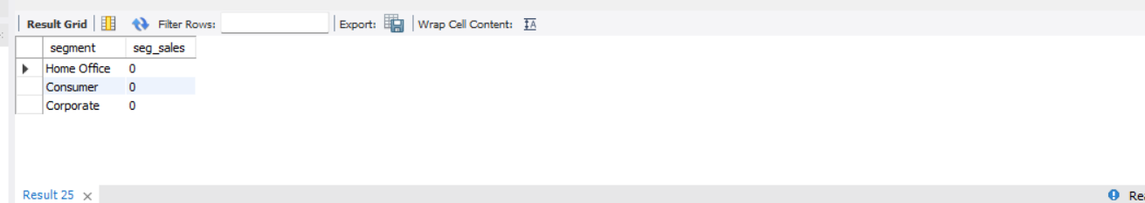
- Find the top 3 most profitable Products.
Code
SELECT
"Product Name" AS product_name,
SUM(Profit) AS total_profit
FROM superstore
GROUP BY Product_Name
ORDER BY total_profit DESC
LIMIT 3;
Result:
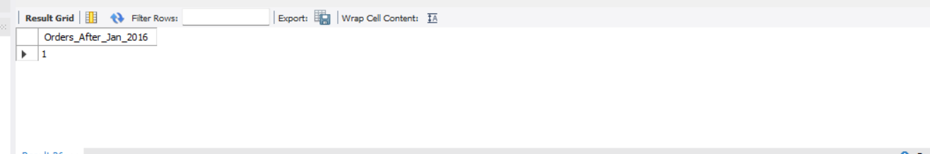
- How many orders are placed after January 2016.
Code:
SELECT
COUNT(DISTINCT "State") AS no_of_state
FROM superstore
WHERE Country = 'Austria';
Result:
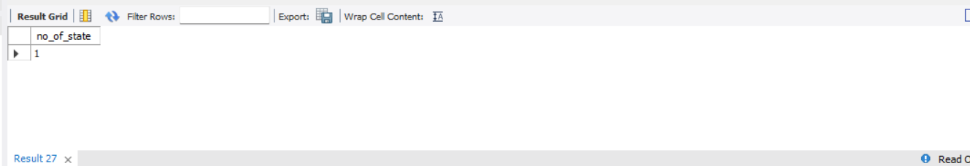
- How many states from Mexico are under the roof of business?
SELECT
COUNT(DISTINCT "State") AS no_of_state
FROM superstore
WHERE Country = 'Austria';
Result:
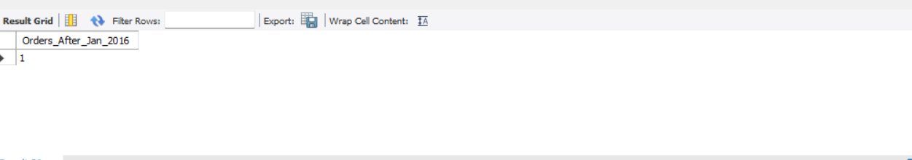

- which products and subcategories are most and least profitable ?
(
SELECT
"Product Name" AS product_name,
SUM(Profit) AS total_profit,
'Most Profitable' AS category
FROM global_superstore
GROUP BY "Product Name"
ORDER BY total_profit DESC
LIMIT 1
)
UNION ALL
(
SELECT
"Product Name" AS product_name,
SUM(Profit) AS total_profit,
'Least Profitable' AS category
FROM global_superstore
GROUP BY "Product Name"
ORDER BY total_profit ASC
LIMIT 1
);
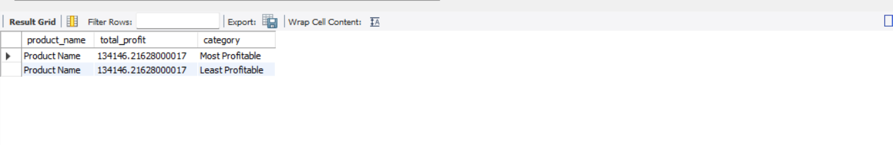
- Which customer segment contributes the most to the total revenue?
Code:
SELECT
Segment,
SUM(Sales) AS total_revenue
FROM superstore
GROUP BY Segment
ORDER BY total_revenue DESC
LIMIT 1;
Result:
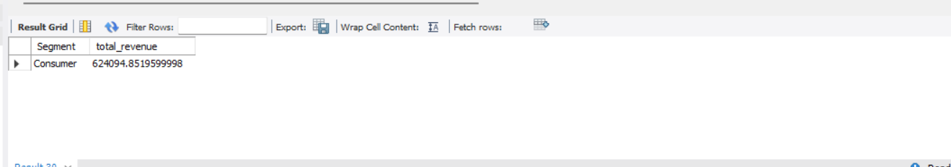
- What is the year-over-year growth in sales and Profit?
Code:
SELECT
Segment,
SUM(Sales) AS total_revenue
FROM superstore
GROUP BY Segment
ORDER BY total_revenue DESC
LIMIT 1;
Result:
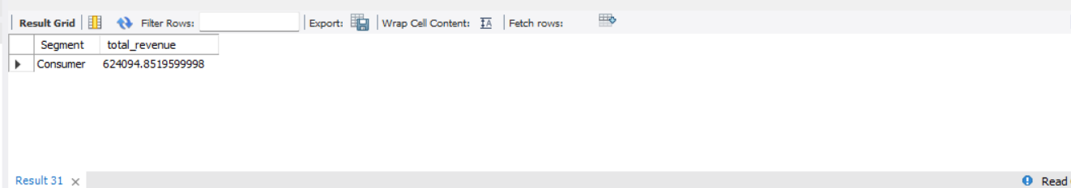
- Which countries and cities are driving the highest sales?
Code:
SELECT
Country,
SUM(Sales) AS total_sales
FROM global_superstore
GROUP BY Country
ORDER BY total_sales DESC
LIMIT 5;

-- Top 5 cities
SELECT
City,
Country,
SUM(Sales) AS total_sales
FROM superstore
GROUP BY Country, City
ORDER BY total_sales DESC
LIMIT 5;
Result:
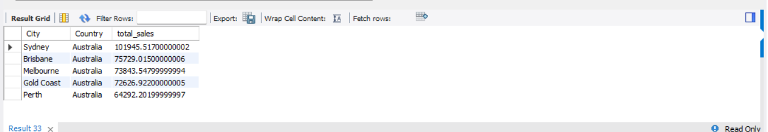

- What is the average delivery time from order to ship date across regions?
Code
SELECT
Region,
ROUND(AVG(DATEDIFF("Ship Date", "Order Date")), 2) AS avg_delivery_days
FROM superstore
GROUP BY Region
ORDER BY avg_delivery_days;
Results:
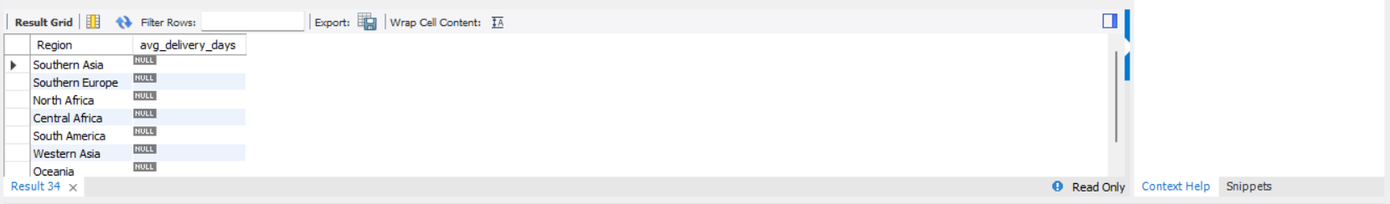

- what is the profit distribution across order priority?
Code:
SELECT
"Order Priority",
SUM(Profit) AS total_profit,
ROUND(AVG(Profit), 2) AS avg_profit_per_order,
COUNT(DISTINCT "Order ID") AS order_count
FROM superstore
GROUP BY "Order Priority"
ORDER BY total_profit DESC;
Result:
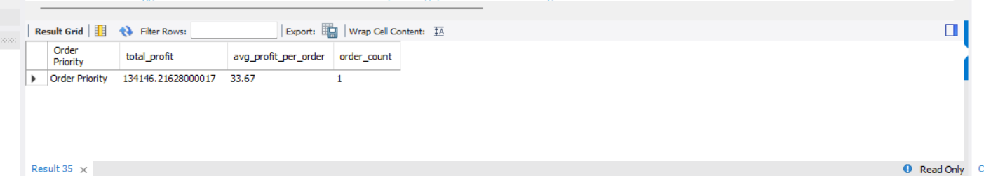
12. Suggest data-driven recommendations for improving profit and reducing losses.
SELECT
ROUND(Discount, 2) AS discount_level,
SUM(Sales) AS total_sales,
SUM(Profit) AS total_profit
FROM superstore
GROUP BY ROUND(Discount, 2)
ORDER BY total_profit ASC;
Result:
